**Ma’lumotlar tuzilmasi va algoritmi**

**F.I.SH. Omonbayev Jaloliddin Ravshanbek o’g’li**

**Guruh: 911-21 guruh talabasi**

**Amaliyot: 10**

**Misol: 17 – raqam .**

**Dasturlash tili: C++ CodeBlocks**

1. Dekning juft elementlari yig’indisini hisoblang

#include<iostream>

using namespace std;

int main(){

int arr[10], i, juft=0;

cout<<"10 ta son kiriting ";

for(i=0; i<10; i++)

cin>>arr[i];

for(i=0; i<10; i++)

{

if(arr[i]%2==0)

juft = juft+arr[i];

}

cout<<"Juft sonlar yig'indisi "<<juft;

cout<<endl;

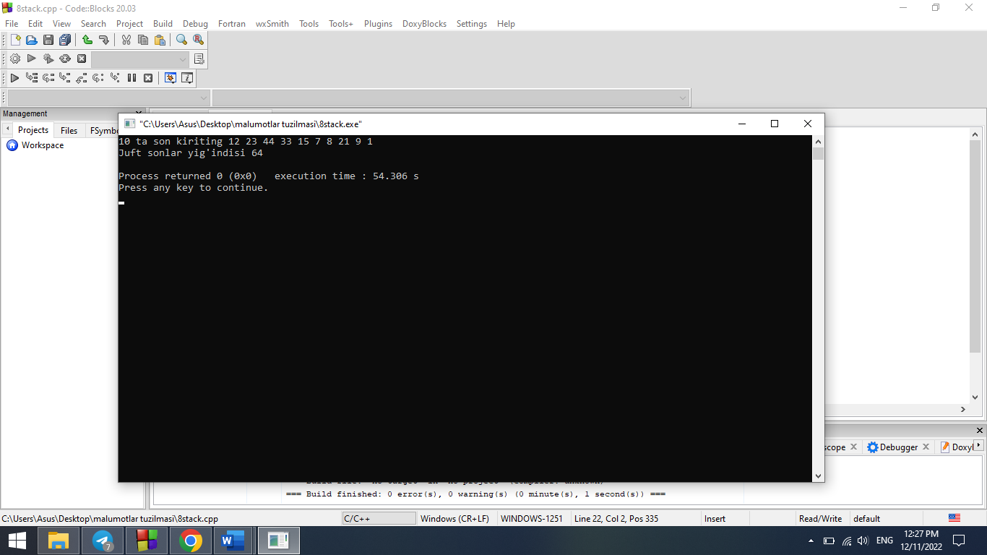 return 0;}

1. Dekdagi manfiy sonlarni o’chiring.

#include<iostream>

#include<deque>

using namespace std;

int main(){

int n; cin>>n;

deque<int>a,b;

for (int i=0; i<n; i++){

int k; cin>>k;

a.push_front(k);

}

while(!a.empty()){

if (a.front()>0)

b.push_front(a.front());

a.pop_front();

}

while (!b.empty()){

cout<<b.front()<<" ";

b.pop_front();

}

}

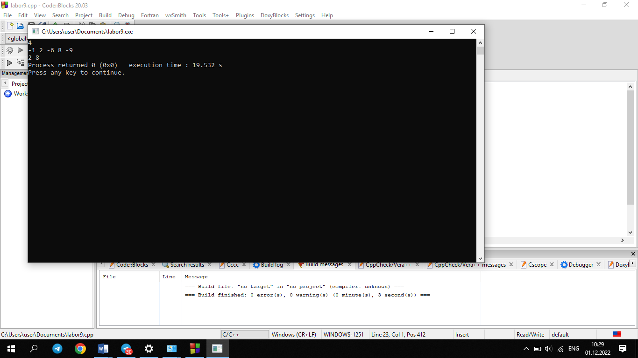

4.Berilgan so’zning unli harflarini dekning chap tomonidan, undoshlarini o’ng tomondan kiriting.

#include<iostream>

#include<cstring>

#include<deque>

using namespace std;

int main()

{

string s;

cout<<"So'z kiriting:";

cin>>s; char x;

deque<char> d;

for(int i=0; i<s.length() ;i++)

{

x=s[i];

if(isalpha(x))

{

if(x=='A' or x=='a' or x=='O' or x=='o' or x=='I' or x=='i' or x=='U' or x=='u' or x=='E' or x=='e')

{

d.push_front(x);

}

else

{

d.push_back(x);

}

}

}

cout<<"Natija...\n";

while(!d.empty())

{

cout<<d.front()<<" ";

d.pop_front();

}

}

